CWT MAX - Model 2
Dual/Single Space Parking Meter
The MAX collects fees for either 1 or 2 parking spaces.

Operational Guide & Overview

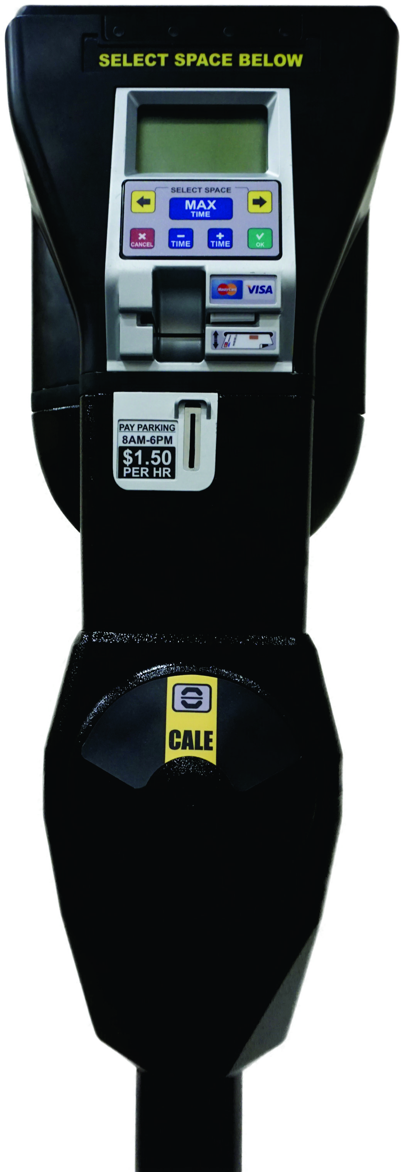

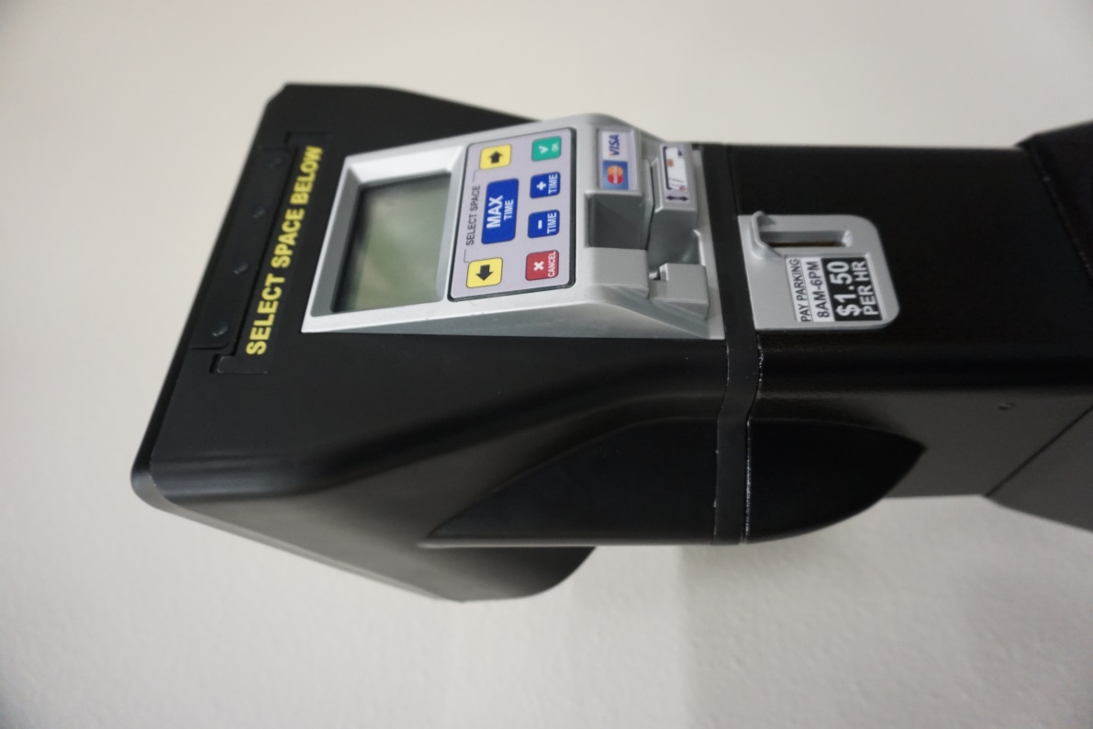

End User - Operational Instructions

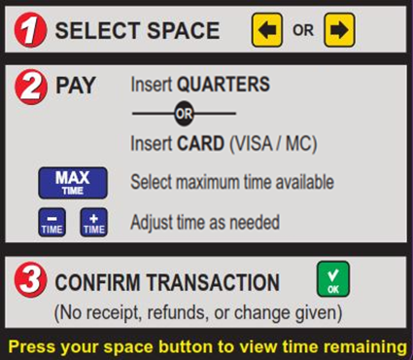
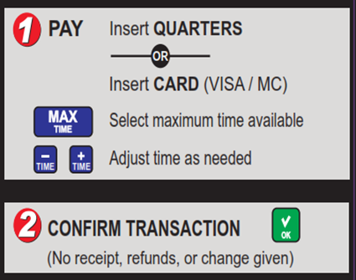
Dual Space Meter Instructions
Single Space Meter Instructions

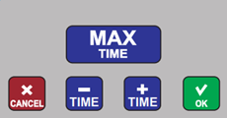

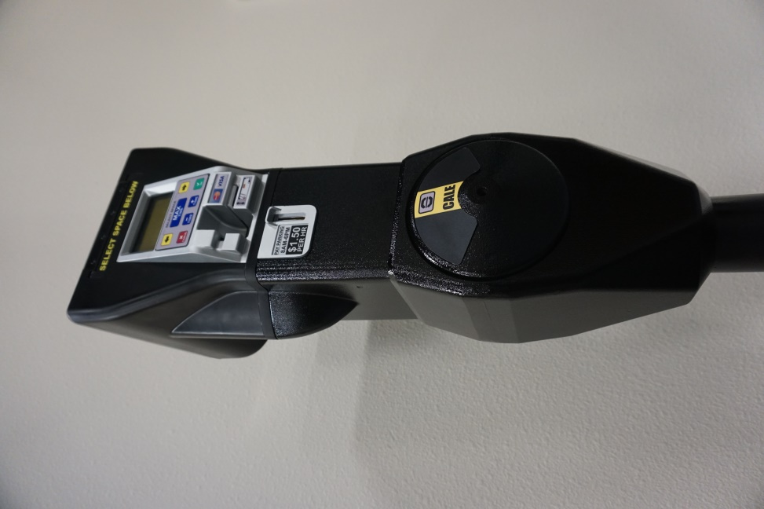

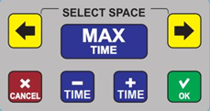

Keypad Buttons

Yellow (ARROWS): Select Space to left or right (on meters configured for Dual Space)
Blue (TIME): For credit card transactions, adjust time with (+) and (-) buttons.
***The MAX Button selects the maximum available time remaining.
Green (OK): Confirms transaction or selection
Red (CANCEL): Cancels displayed option

MAX Meter Layout
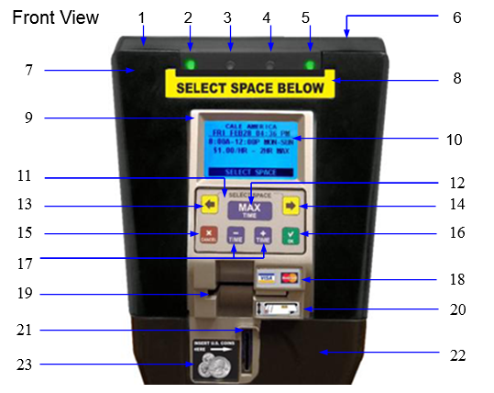

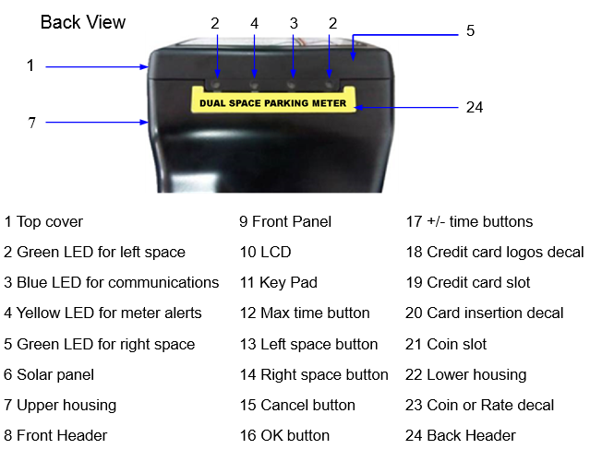

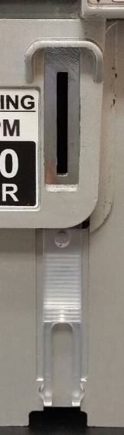
Coin Jam Tool:

A coin jam tool is located behind the coin inlet and is hidden by the lower housing. After the top housing is removed, pull the meter out of the lower housing and remove the tool from the mechanism by pressing a thumb against the ridges and sliding the tool downward. (The coin inlet will also come out, so make sure you don’t lose it.)

Use the tool to gently remove any jammed coins or foreign objects. If necessary, you may also remove the coin validator in order to remove jammed coins or foreign objects.

MAX Operational Overview
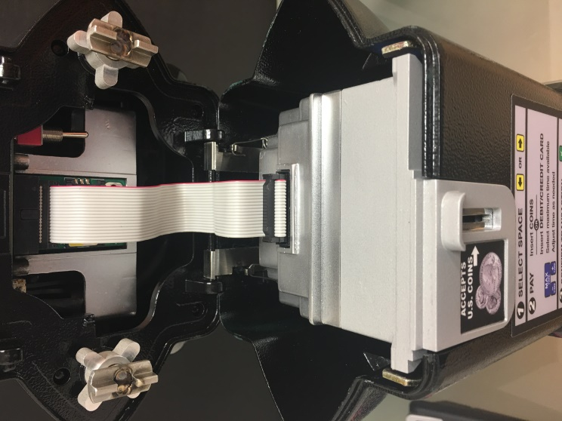
Power On

With the top housing flipped open, toggle the Power Switch located on the right side of meter to turn it on.

Display

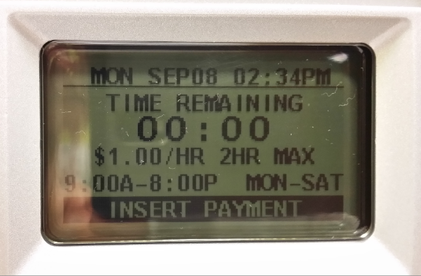

Credit card slot

Cards are inserted here to pay for parking. A white block at the entrance of the card slot reduces water intrusion and lifts up to allow entry when a card is inserted.

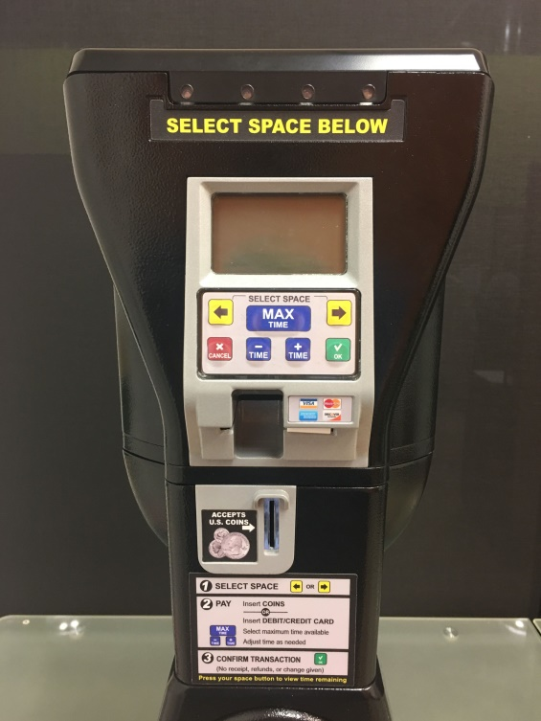
Coin Slot

Insert coins to pay your parking fee. There is a sliver-plated entrance part, which can be changed to other sizes, so the coin denomination can be restricted. And there is a plastic clip which can be used to clean the foreign things of coin slot.
LED Light Indicators

Green LED at top left or right blinks if time remains on that indicated space
Blue LED blinking = 3G communications issue
Yellow LED blinking = event warning (coin box full, low battery, coin jam, etc.)

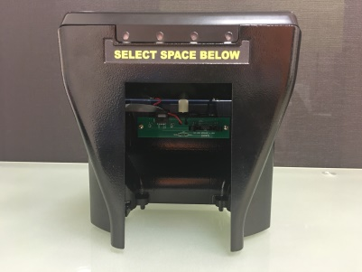
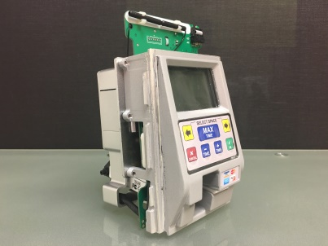
Mechanism
Upper housing
Lower housing
MAX Model 2 – Installation Process

1. Attach battery to grey cover using existing Velcro and connect battery plug. (Be sure to clip cover back into Mechanism)

2. Connect ribbon cable (as shown) and slide Mechanism into upper housing.

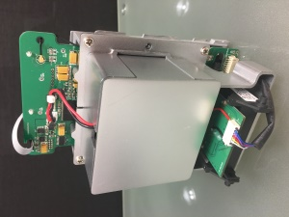
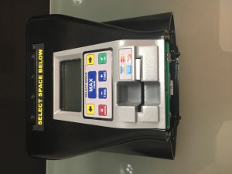
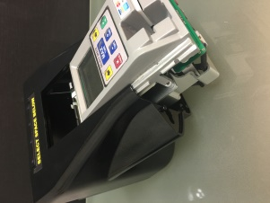
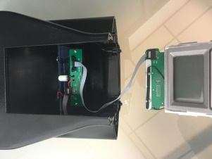
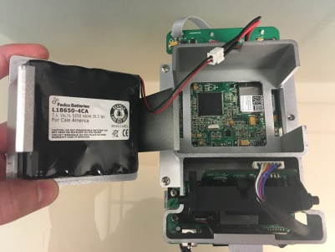

3. Mount middle bracket to bottom of upper housing and tighten the fixed silver screws.

4. Attach complete upper unit using the hooks on lower housing and prepare coin unit.

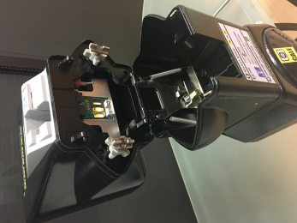
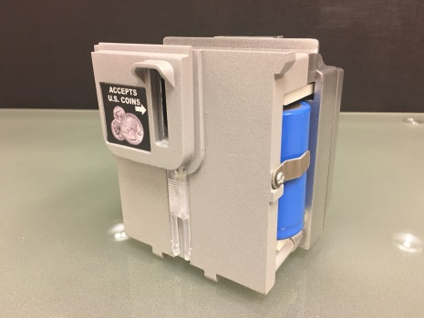
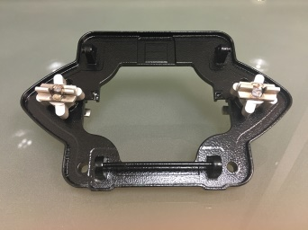
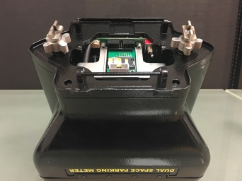

5. Place coin unit into lower housing and connect ribbon cable.

Hardware installation complete.

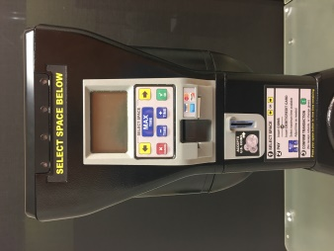
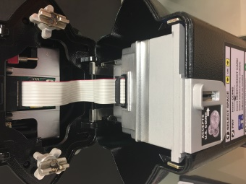
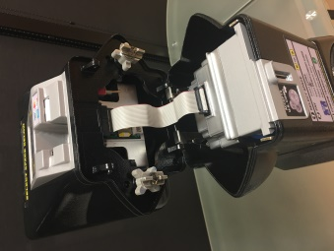

Cale Web Office (CWO2) & Terminal Management
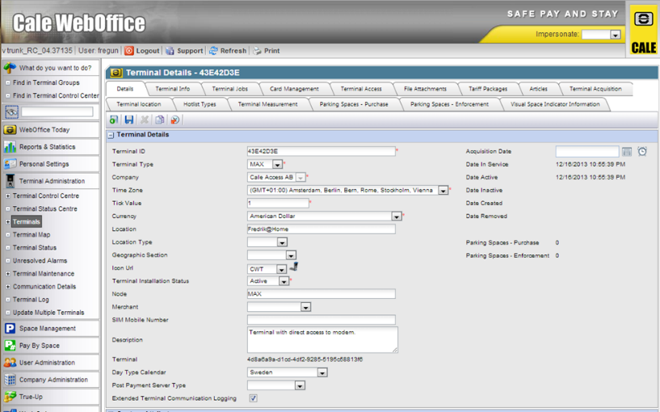
The status of all Cale meters can be monitored using Cale’s Web Office Parking Management System (CWO2). Alerts and purchase totals can be tracked, and meter issues reported on CWO2 can be communicated to field technicians via call, text, or email.
TERMINAL SYSTEM MENU
You may want to access a meter’s system menu in order to:
- Check status of a meter whose flashing yellow LED indicates a problem
- View meter performance levels such as battery voltage or communications signal strength
- View meter data or statistics such as coin balance, # of transactions, event warnings, etc.
- Perform a special command such as Force Heartbeat (communications), Warm Reboot, etc.
- Reconfigure a meter’s settings
MAX terminal system menus can be viewed with the use of an access card or by entering a button sequence and log-in credentials. Three different cards are available with the following access levels:
1) Access: This highest level access card allows users to view all system menus, initiate monetary collection commands, and make changes to important system settings such as Global User ID, Web IP Address, Credit Card Terminal ID, Cellular Gateway, and more.
2) Limited Access: The limited access card allows users to view system menus and perform a limited number of functions, such as ‘Force Heartbeat’, and ‘Warm Reboot’.
3) Collection: The collection card allows users to initiate coin and credit card collection commands. In absence of a collection card, a log-in sequence may also be assigned to perform collections. Once the service menu has been accessed, you may navigate down or up by pressing the + or – buttons. Select any option by pressing OK, and return to a prior screen by entering CANCEL. Totals will be communicated to Cale’s online CWO2 back office and reset to zero at the meter.

TERMINAL SYSTEM MENU (cont.)
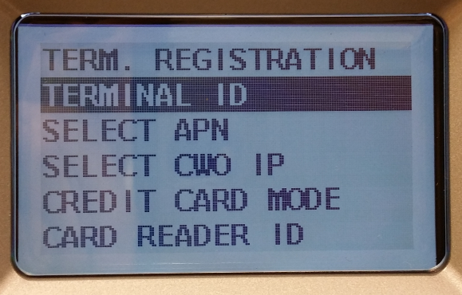
System Settings is used to register and set up the terminal’s ID, cellular configuration, Cale IP address, credit card mode, terminal guid and more.

Troubleshooting the MAX:
- Display blank or frozen: Indicate batteries may be low and communications ceased. If buttons are responsive, try to get meter to communicate to CWO2 by ‘Forced Heartbeat’. If that fails, reboot.
- Display shows Terminal Registration menu: Meter has lost some, or all, of its programming and needs to be reprogrammed.
- Coins not registering: May be because software configuration jobs haven’t downloaded due to low batteries or com failure. If not, then need to replace meter.
- Cards not processing: May be due to low batteries or com failure. If not, replace meter.
Forced Heartbeat: Enter System Menu, select System Settings, Com Settings, and Forced Heartbeat. After heartbeat forced, press cancel back to main screen. Observe top left of display to see if a series of letters appear. If “T” and “R” appear, then Transmission and Receiving of data has occurred.
Reboot: If buttons are unresponsive, reboot meter. Turn off, wait 10-15 seconds, and turn on. Look for data transmission per above. In either case, batteries are most likely low, so measure voltage for all and replace if necessary. Main batteries should be around 7v – 8v and backup batteries should be near 3.6v (Each).
Reprogram Meter: Meter(s) can be reprogrammed via web office (CWO) as long as the terminal is communicating properly.
For offline programming, connect terminal to PC via ST-Link USB cable and install the appropriate firmware followed by your City or companies configuration file.
(Note: Manual programming is reserved for Cale technicians, unless proper training and tools have been given. For more information about Max training, please contact the Cale help desk).
Register Meter: Follow instructions to register meter to CWO2 production server using assigned client Parking ID # and CWO2 IP address.

