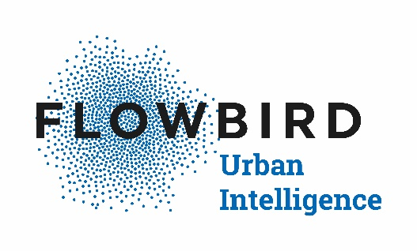February 17, 2022

Dear Flowbird Client:

I am writing to announce the End of Life (EOL) of Flowbird’s MP104 Pay Station. Flowbird is committed to providing clients with a high level of customer service and system flexibility. The MPC meter software platform was introduced in 1996, and due to technology obsolescence, we will not be able to properly support this product past **June 30, 2023.**

**Customer Support**

Flowbird will continue to provide customer support for the MP104 via chat, email, phone, and on-site service as needed, until the EOL date. The Flowbird team will also accommodate rate changes as needed, and will provide quotations for any necessary software programming prior to performing the work.

**Parts Availability**

The majority of the main components of the MP104 are no longer manufactured. Flowbird does have refurbished parts inventory in stock, however, future availability is not guaranteed.

**MP104 Upgrade Option**

We have created an upgrade path for the MP104 which utilizes the existing MP104 cabinets. The upgrade kit provides you with all new internal components, and features a full color touch screen display providing end users with an enhanced parking experience. For clients that already upgraded their MP104 modems to 4G technology in 2020 or 2021, Flowbird will reuse your new modems and antennas in the upgrade kit, and provide a discount equal to the purchase amount of the modem upgrade.

We appreciate your business, and look forward to working with you to optimize your parking system for the future. Please contact your Flowbird Business Development Manager or local Flowbird distributor if you have any questions.

Best Regards,



Sean Renn

Vice President of Marketing & Communications, Flowbird North America

sean.renn@flowbird.group